**NAAN MUDHALVAN**

SALESFORCE ASSIGNMENT

COLLEGE : **PSN INSTITUTE OF TECHNOLOGY AND SCIENCE**

NAME : KALEESWARAN V

REG NO : 952420104012

NM ID : 188870D71E130D9B4DC4199E6163494C

**Task – 1 :**

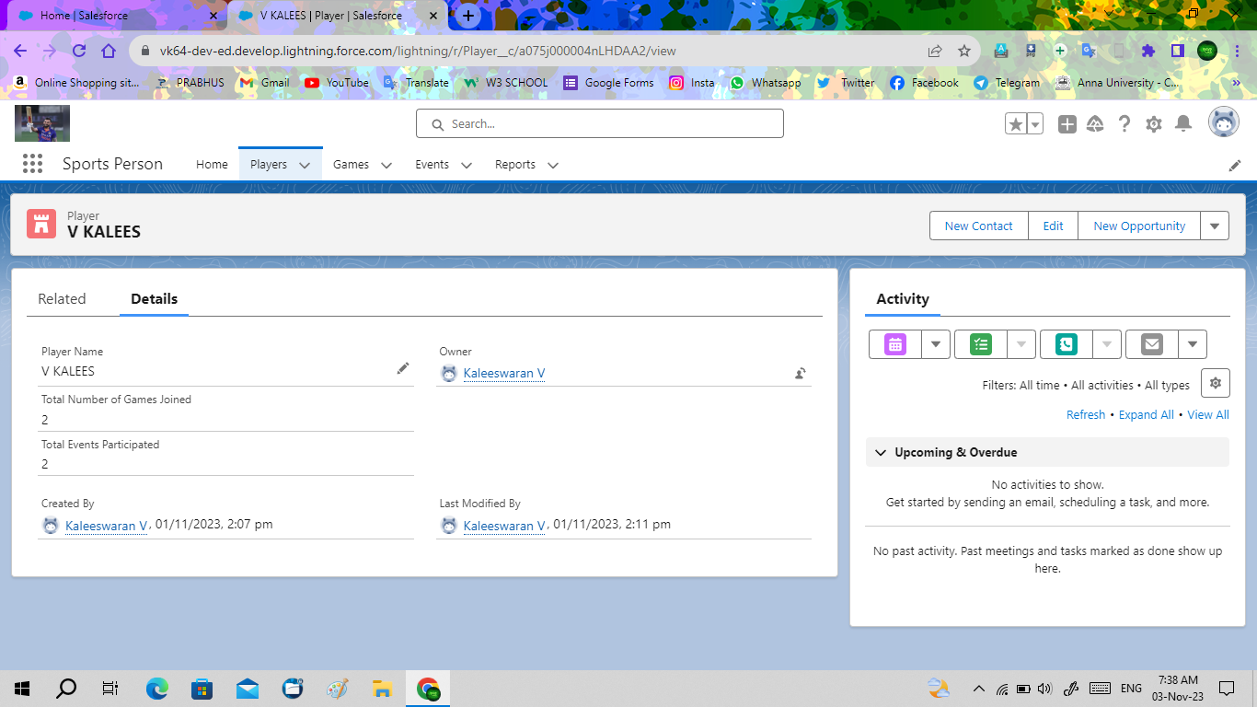

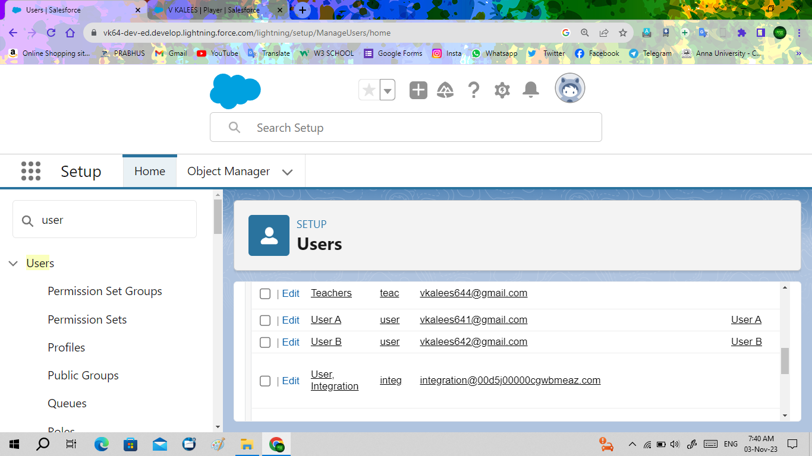**Task – 2 :**

**Task – 3 :**

**Task – 4 :**

